PROJECT

**GroceryGenius: Smart Grocery Shopping Assistant with Basket Analysis**

VIGNANA BHARATHI INSTITUTE OF TECHNOLOGY

Team members

20P61A04A2

ROSHINI.K(team lead)

20P61A0482

K.KARTHIK

20P61A0496

K.SATHVIKA

20P61A0498

K.SRINIVASA CHARY

Introduction

Retailers employ the data mining approach of market basket analysis to gain insight into their consumers' shopping habits. It is determining which products are regularly bought in tandem with one another.

# Market basket analysis:-

• A data mining method called market basket analysis is used to find connections between products that are regularly bought together in transactions. Market basket analysis, sometimes referred to as association analysis or affinity analysis, looks for associations or patterns of co-occurrence between the products that consumers purchase.

# Applications:-

Applications for Market Basket Analysis include:

Market basket analysis has a wide range of applications beyond just understanding customer purchasing patterns in retail. Here are some key applications:

1. Cross-Selling and Upselling: Retailers can use market basket analysis to identify items that are frequently purchased together and then leverage this information for cross-selling or upselling strategies. For example, if customers frequently buy cameras and memory cards together, the retailer can promote memory cards to customers purchasing cameras.

2. Inventory Management: Understanding which items are frequently purchased together allows retailers to optimize inventory management by ensuring that related items are stocked together or adjusting inventory levels based on demand patterns.

3. Promotion Planning: Market basket analysis helps in planning effective promotions and discounts. Retailers can offer bundle deals or discounts on related items to incentivize customers to make additional purchases.

4. Store Layout and Product Placement: Insights from market basket analysis can inform decisions about store layout and product placement. Related items can be placed closer to each other to encourage cross-selling, and high-demand items can be strategically placed in high-traffic areas of the store.

5. E-commerce Recommendations: Online retailers can use market basket analysis to enhance recommendation systems. By recommending related products based on past purchase behavior, e-commerce platforms can improve customer experience and increase sales.

6. Supply Chain Optimization: Manufacturers and suppliers can use market basket analysis to understand demand patterns and optimize their supply chains accordingly. This can help in improving production planning, reducing stockouts, and minimizing inventory holding costs.

7. Customer Segmentation: Market basket analysis can contribute to customer segmentation efforts by identifying groups of customers with similar purchasing patterns. This information can be used to tailor marketing campaigns and offers to different customer segments effectively.

8. Fraud Detection: In industries like banking and insurance, market basket analysis can be used for fraud detection. By identifying unusual combinations of products or services purchased together, anomalies indicative of fraudulent behavior can be detected.

Overall, market basket analysis is a versatile tool with applications across various industries, helping businesses make data-driven decisions to improve efficiency, profitability, and customer satisfaction.

# Purpose:-

The purpose of a Smart Grocery Shopping Assistant with Basket Analysis is to enhance the grocery shopping experience for consumers and optimize operations for retailers. Here's how:

1. Personalized Shopping Experience: By analyzing a shopper's past purchase history and preferences, the assistant can provide personalized recommendations for products, recipes, and promotions tailored to their needs. This enhances customer satisfaction and loyalty.

2. Efficient Shopping Lists: Leveraging basket analysis, the assistant can suggest items that are frequently purchased together, helping shoppers create more efficient shopping lists. It can also remind them of any forgotten items, streamlining the shopping process.

3. Budget Management: The assistant can help shoppers stick to their budget by suggesting lower-cost alternatives or notifying them of ongoing promotions and discounts on items in their basket.

4. Healthier Choices: With access to nutritional information and dietary preferences, the assistant can recommend healthier alternatives or suggest balanced meal plans based on the items in the shopper's basket, promoting healthier eating habits.

5.Optimized Inventory Management: By analyzing basket data across multiple shoppers, retailers can gain insights into demand patterns and adjust their inventory levels accordingly. This helps minimize stockouts, reduce wastage, and ensure that popular items are always available.

6. Targeted Marketing and Promotions: Retailers can use basket analysis insights to tailor marketing campaigns and promotions more effectively. By understanding which products are frequently purchased together, they can create targeted offers and incentives to drive sales and customer engagement.

Overall, a Smart Grocery Shopping Assistant with Basket Analysis aims to make grocery shopping more convenient, personalized, and efficient for consumers while helping retailers optimize their operations and drive business growth.

# Steps followed:-

* Data Preparation
* Algorithm Selection
* Association Rule Mining

# Data preparation:-

* Before running Market Basket Analysis, ensured data is properly formatted:
* - Transaction data in a tabular format with each row representing a transaction and columns representing items purchased.

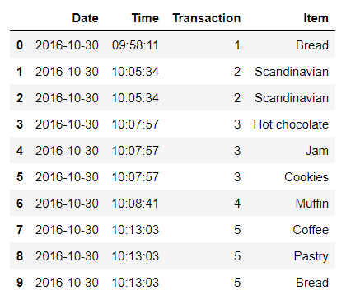

## Algorithm selection

* Apriori Algorithm: Popular for its simplicity and efficiency in finding frequent itemsets.
* The Apriori algorithm is a classic algorithm used for association rule mining in transactional databases. It is designed to discover frequent itemsets within a dataset and generate association rules based on these itemsets. The algorithm is widely used in market basket analysis and other applications where the goal is to uncover relationships between items in transactions.

# Association rule mining

* Perform association rule mining on your dataset:
* - Set minimum support and confidence thresholds.
* - Identify frequent itemsets and generate association rules.
* - Interpret the results to derive meaningful insights

# Interpreting result

* Understand and interpret the results obtained from Market Basket Analysis:
* - Identify strong association rules (e.g., {Milk, Bread} -> {Eggs}).
* - Analyze support, confidence, and lift metrics to prioritize rules.

# Implementation

* Demonstrate how to implement Market Basket Analysis using code snippets or examples:
* Python with libraries like mlxtend or pandas

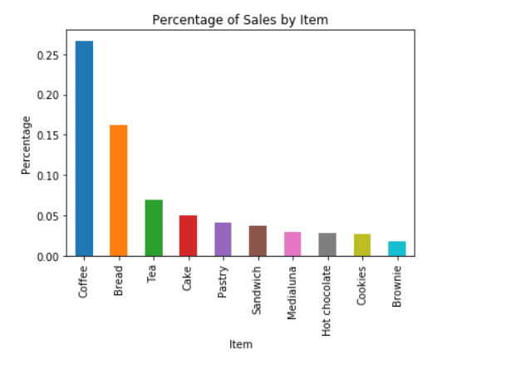

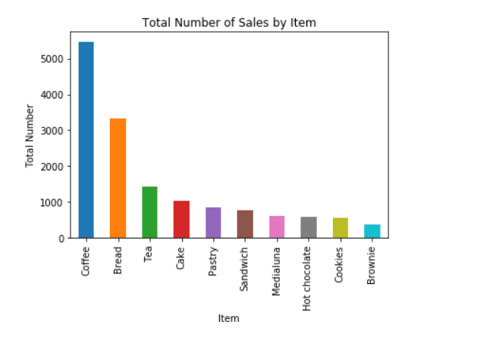

OUTPUTS

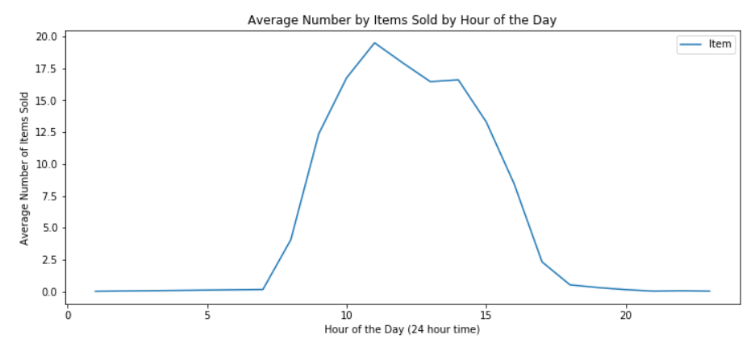

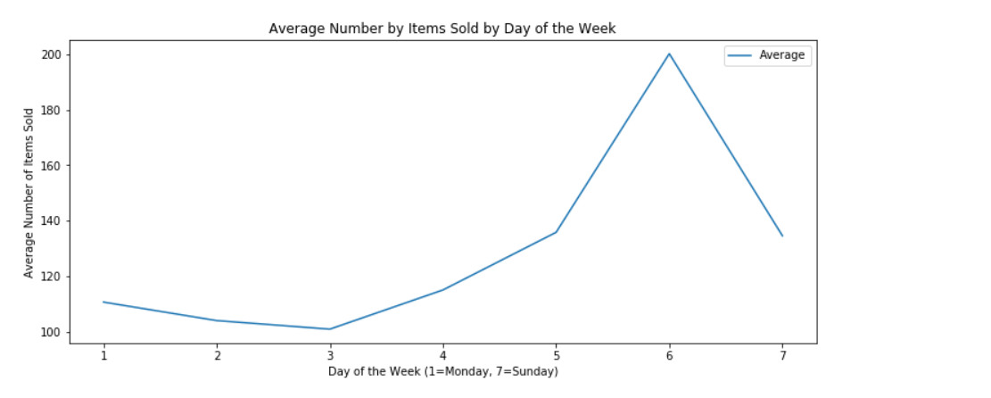

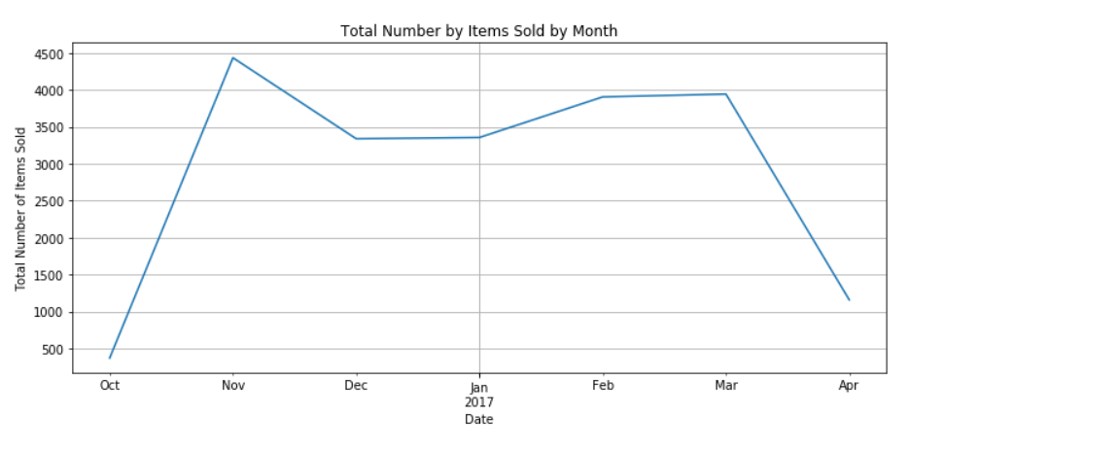

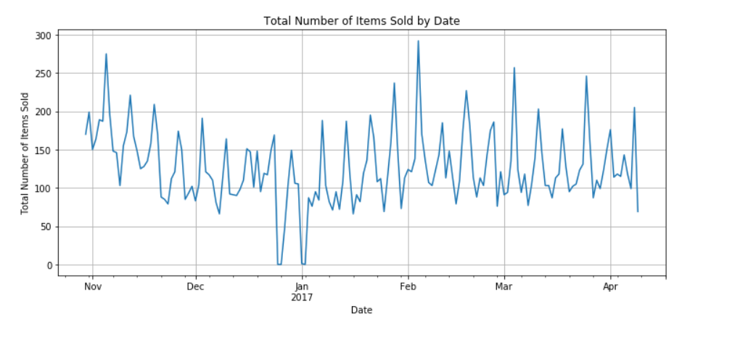

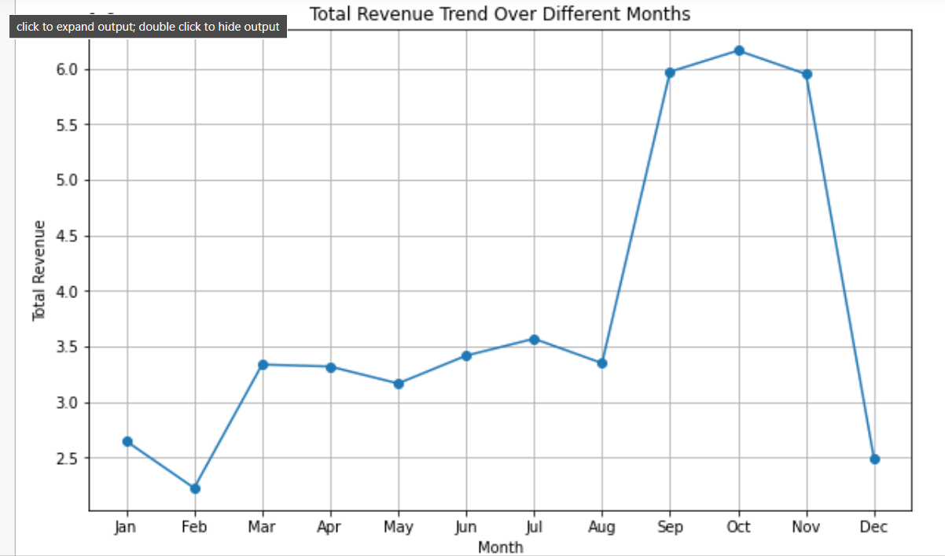

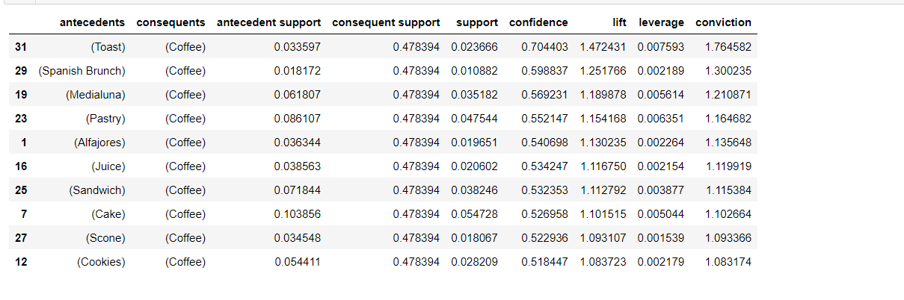

# Case studies

1. Problem Statement

A grocery store wants to understand customer purchasing behavior to optimize product placement and promotional strategies. The store aims to identify which items are frequently bought together and generate actionable insights for improving sales and customer experience.

2. Data Collection

The grocery store collects transaction data over a period of one year, recording the items purchased together in each transaction.

3. Data Exploration

Dataset: Transaction data containing lists of items purchased together.

Example dataset:

TransactionID Items

1 Bread, Milk

2 Bread, Butter

1. Milk, Butter

Data Preparation:

* Convert the transaction data into a suitable format for market basket analysis, such as a list of lists representing transactions.

4. Market Basket Analysis Process

* a. Data Preprocessing
* Convert Data: Transform the transaction data into a one-hot encoded format suitable for analysis.
* b. Generate Frequent Itemsets
* Apriori Algorithm: Use the Apriori algorithm to identify frequent itemsets (sets of items that occur together frequently).
* c. Generate Association Rules
* Association Rule Mining: Use association rule mining to derive meaningful rules from the frequent itemsets.

5. Interpretation of Results

Frequent Itemset:

- Identify which item combinations are frequently purchased together (e.g., Bread and Milk).

Association Rules:Discover relationships between items, such as if a customer buys Bread, they are likely to also buy Butter (confidence=0.7).

* 6. Insights and Recommendations

Based on the market basket analysis results:

- Place frequently co-purchased items closer to each other on shelves to encourage cross-selling.

- Design targeted promotions and discounts for item combinations identified as strong associations.

- Optimize inventory management based on popular item combinations to meet customer demand.

* 7. Implementation and Monitoring

Implement the recommended strategies derived from market basket analysis and continuously monitor customer purchasing patterns to refine strategies and improve business outcomes.

This case study outlines the steps involved in performing market basket analysis for a grocery store, from data collection and preprocessing to generating insights and actionable recommendations. Customize the analysis based on specific business goals and datasets to derive valuable insights for enhancing retail operations and customer satisfaction.

# Conclusion

The Apriori algorithm effectively generates highly informative frequent itemsets and association rules for the data of the supermarket. The frequent data items are generated from the given input data and based on the frequent item stets strong association rules were generated